**EXPERIMENT- 4**

**Case Study 3& 6 (WAREHOUSE SYSTEM)& (PAINITING HIRE BUSINESS)**

PRE-LAB:

1.Generally to obtain a ER Diagram we follow the approach of generalization. Make a note on some properties regarding this approach?

2. Mr.Jack states that the Specialization process starts from a single entity set and it creates a different entity set by using some different features. But Mr.John says that the specialization process  starts with the number of entity sets and it creates high-level entities with the help of some common features. Whom do you support and justify your answer?

3.Match the following:

Column A Column B

i) Each column in a Table. Attributes are the properties which define a relation.  A. relation key

 ii) Every row has one, two or multiple attribute B. cardinality

iii) It represents the name of the relation with its attribute C. attribute

iv) Total number of rows present in the Table. D. degree

v) The total number of attributes which in the relation  E. Relation Schema

4. The basic idea of an organized database is of a Relational model. Describe its advantages.

5. Integrity is a property of a database that ensures accuracy in the data. State some constraints used to enforce this integrity.

6. Explain the concept of instance in a database.

IN-LAB:

Draw an ER Diagram for a given Case Study 3

## **CASE STUDY 3: WAREHOUSE SYSTEM**

## Our company has several warehouses, each warehouse is designated by a unique 4-letter symbol (by a letter we mean a..z and A..Z). Each warehouse has several bins that are identified uniquely by numbers (unsigned integers), i.e. each warehouse has bins 0, 1, 2, 3, … Each bin has a particular capacity. In our warehouses (more precisely in the bins in our warehouses) we store parts. Each part is designated by a unique part number (a 5- symbol sequence of digits and letters). Several parts together can form another part. We call such a part “assembly”. In the warehouses we store only the constituent parts, but we record the assemblies in our database as it were a part. Assemblies cannot be parts of other assemblies. A part can be a constituent part in at most in one assembly parts arrive in batches. Each batch for a particular part has a unique batch number (unsigned integer) and arrives on a particular date. Each batch has a size, i.e. the number of items in the batch. All items from the same batch are stored together in the same bin (no batch is stored in more than 1 bin). Each item in a batch has a unique item number (unsigned integer). For example: part A1, batch 27, item 1 or part A1, batch 23, item 1 etc. When a batch arrives, its date-in is recorded. A particular manager checks its arrival, and this fact must be recorded in the database. Some parts may be backordered. A part can be backordered only by a manager. The manager, the date of the backorder are recorded, and also the quantity backordered. When a backorder shipment arrives, the backorder’s remaining quantity is updated (the number of items arrived is subtracted from the remaining quantity), and if it is less or equal to 0, the backorder is deleted, but must be kept for record. There may be only a single current (active) backorder for any parts. Assemblies cannot be backordered, only their constituent parts. When an item is shipped out of the warehouse, its date-out is recorded together with the employee who checked its shipping. Employee has a unique employee number (a 6-digit number), phone number(s) (it consists of a 3-digit area code and a 6-digit number an employee can have 0 to many phone numbers), name(s) (it consists of an up=to-10-characters fist name, an up-to-10- characters middle name, and an up-to-20-characters last name, an employee can have 1 to many names), address(s) (it consists of an up-to-6-characters street number, an up-to-20- characters street name, an up-to-20-characters city name, and a 2-character abbreviation of the province, an employee can have 1 to many address). Some of the employees are managers. Every employee who is not a manager works under supervision of a single manager. Managers do not work under other managers.

Draw an ER Diagram for a given Case Study 6

## **CASE STUDY 6: PAINITING HIRE BUSINESS**

A local businesswoman has decided to start her own Internet business, called Masterpieces Ltd, hiring paintings to private individuals and commercial companies.   Because of your reputation as a database designer she has called upon your services to design and implement a database to support her new business. At the initial planning meeting, to discuss the design, the following user requirements were requested. The system must be able to manage the details of customers, paintings and those paintings currently on hire to customers. Customers are categorized as B (bronze), S (silver), G (gold) or P (platinum). These categories entitle a customer to a discount of 0%, 5%, 10% or 15% respectively. Customers often request paintings by a particular artist or theme (eg animal, landscape, seascape, naval, still‐life, etc).

Over time a customer may hire the same painting more than once. Each painting is allocated a customer monthly rental price defined by the owner. The owner of the painting is then paid 10% of that customer rental price. Any paintings that are not hired within six months are returned to the owner. However, after three months, an owner may resubmit a returned painting. Each painting can only have one artist associated with it. Several reports are required from the system. Three main ones are: 1. For each customer, a report showing an overview of all the paintings they have hired or are currently hiring 2. For each artist, a report of all paintings submitted for hire 3. For each artist, a returns report for those paintings not hired over the past six months Remember to identify key attributes and any foreign key attributes.

POST-LAB:

1.In the given below statements choose the correct option and explain why?

i) A superkey is an attribute or a group of multiple attributes that can uniquely identify a tuple

ii) A superkey is a tuple or a set of multiple tuples that can uniquely identify anattribute

iii) Every superkey is a candidate key

iv) A superkey is an attribute or a set of attributes that distinguish the relation fromother relations

2.From the above ER diagram convert it into relational schema?

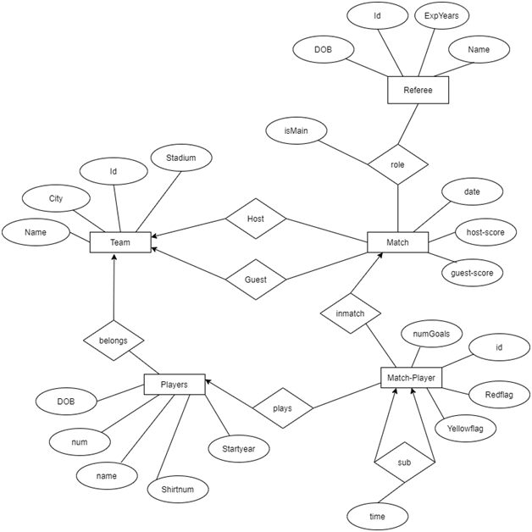

3. What is the minimum number of tables needed to represent M, N, P, R1, R2

